SETUL MINIM DE TESTE

NR.5

TABELUL DE ADEVAR



SCHEMA BLOC

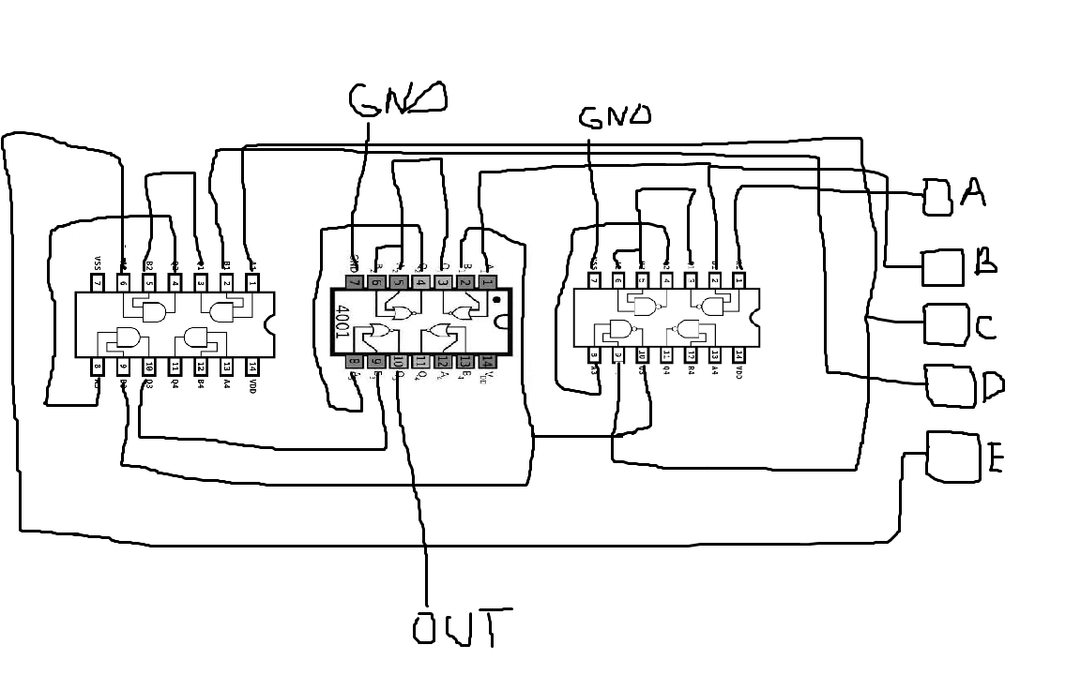

CIRCUIT

COD ARDUINO

int timer = 100;

boolean circuitOK;

int rez;

void setup() {

  pinMode(8, OUTPUT)

  pinMode(9, OUTPUT);   //set pin as output , d line

  pinMode(10, OUTPUT);   //set pin as output , c line

  pinMode(11, OUTPUT);   //set pin as output , b line

  pinMode(12, OUTPUT);    //set pin as output , a line

  pinMode(4, OUTPUT); //set pin as test result

  Serial.begin(9600);    //start serial communication @9600 bps

  }

void loop(){

      /\*

      test the circuit with the following test set

      0011->0,1111->0

      \*/

      circuitOK = true;

      digitalWrite(4, LOW);

      for (int thisTest = 1; thisTest <2; thisTest++){

          if (thisTest ==1){

            //write values on input lines

            digitalWrite(12, LOW); //a line

            digitalWrite(11, HIGH); //b line

            digitalWrite(10, HIGH); //c line

            digitalWrite(9, LOW); //d line

            digitalWrite(8, LOW);

            delay(timer);

            //read z line value

            rez = digitalRead(7);

            if (rez != 1){

              circuitOK = false;

            }

            }

            if (thisTest ==2){

            //write values on input lines

            digitalWrite(12, HIGH); //a line

            digitalWrite(11, HIGH); //b line

            digitalWrite(10, HIGH); //c line

            digitalWrite(9, HIGH); //d line

            delay(timer);

            rez = digitalRead(7); //read z line

            if (rez != 0){

              circuitOK = false;

            }

            }

       if (!circuitOK){

        break;

      }

          }

      }